2007 Emerging Healthcare Trends (From ACHE website)

Authorities offer their insights on the hottest topics in healthcare including these trends:
- The increased levels of transparency on cost and quality at the individual hospital and individual physician level will be a divisive force among providers and even within integrated groups.
- Consumer-driven insurance innovations will cause a massive restructuring of the healthcare sector.
- CEOs and other senior executives will be increasingly held accountable for achieving high performance with measured results.
- Payers and government will push for better disclosure of what services cost, making price transparency an expectation.
- Increasing numbers of physicians will demand reimbursement for input, call, and citizenship activities.
- Hospitals will continue to increase the use and expand the scope of practice of advanced practice nurses and physician assistants.
- Hospitals will continue to take advantage of the current period of relative financial stability to make important capital investments.

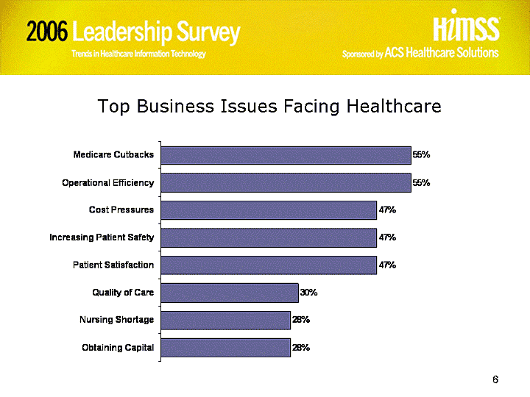
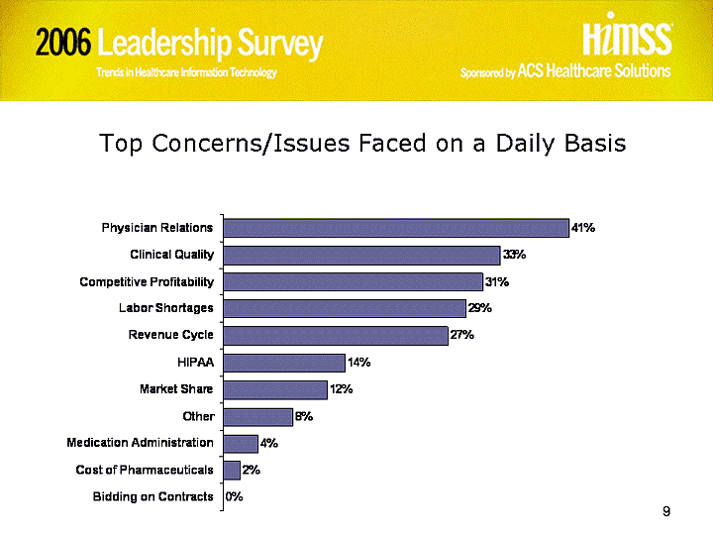
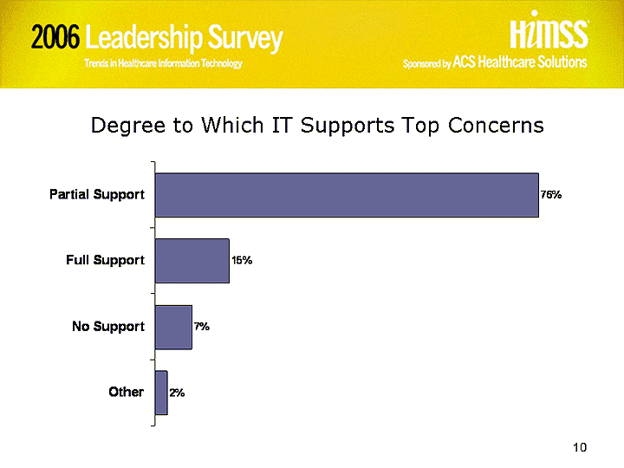

IT Priorities
Respondents identify physician relations as the issue they deal with on a daily basis followed closely by clinical quality; patient (customer) satisfaction and Medicare/Medicaid cutbacks are two top issues that will affect healthcare in the next two years, they say. More than three-quarters of the respondents indicated that their IT plan mirrors the organizational strategic plan; and half reported that the CIO at their facility was considered part of the executive team. Forty percent of respondents indicate that IT fully supports the issues they deal with on a daily basis; a similar number indicated that they had a high degree of confidence in their IT departments to deliver on-time, on-budget projects.
When asked to identify the business issues that would affect healthcare in the next two years, respondents were most likely to identify patient (customer) satisfaction by 65 percent of the respondents followed by Medicare/Medicaid cutbacks 57 percent of the respondents. Forty-eight percent of the respondents identified increasing patient safety. Improving quality of care and cost pressures were each identified by over 40 percent of respondents.
Respondents also were asked to identify the two concerns or issues that they consistently dealt with on a daily basis. Topping the list was physician relations, which was identified by 55 percent of respondents. This was followed by clinical quality (52 percent) and labor shortages (32 percent). At the bottom of the list were pharmaceutical costs (3 percent) and bidding on contracts (2 percent).
When asked if IT supported the concerns identified above, forty percent of the respondents said IT fully supports the concerns that they deal with on a daily basis, while almost half of the respondents (46 percent) indicated that IT provided them with partial support. Only five percent of the individuals responding to this survey indicated that IT offered them no support in dealing with the challenges they face daily.
The respondents were asked how closely their facility’s IT strategic plan mirrors their organization’s business plan. Almost a third of respondents (34 percent) indicated that their facility’s IT plan mirrors the strategic plan of the organization. Another 43 percent indicated that the alignment was somewhat close. A substantial portion of the respondents (14 percent) suggested that alignment between an IT strategic plan and the organizational plan was not at all closely aligned.
The respondents were asked to identify barriers to successfully implementing IT solutions that will improve patient care today. Twenty-three percent of respondents note that there is a lack of adequate financial support for IT at their organization. Another 22 percent indicate that difficulty in achieving end-user acceptance or use. More than one in ten respondents said vendor's inability to effectively deliver product or service to their satisfaction (14 percent) and lack of strategic IT plan/failure to implement IT plan (12 percent) were barriers.
Respondents also were asked to identify the biggest frustration they encountered regarding the use of information technology at their facilities. More than a quarter of the respondents (28 percent) mentioned escalating costs as the biggest frustration followed by clinical leadership (21 percent) and measuring value (20 percent). Twelve percent of respondents indicated that they had no frustrations with respect IT.
Respondents represented in this study are reasonably confident that their organization’s IT department will consistently deliver on-time, on-budget projects. Fifty-three percent of respondents indicated that they had some degree of confidence in their IT department, with another 37 percent indicated that they had a high degree of confidence in their IT department. Seventeen percent of respondents reported that they had little confidence in their IT department to consistently deliver on-time, on-budget projects and two percent indicated that they have no confidence.
Additionally, slightly more than half of the respondents in this sample, 51 percent, indicated that the CIO at their organization is considered part of the executive team.
More than three-quarters (80 percent) of the respondents in this survey indicated that their facilities IT operating budget would definitely or probably increase for 2006. Specifically, just over 37 percent of the respondents indicated that the IT operating budget at their facility would definitely increase in 2006; 43 percent indicated that such an increase was probable. Twelve percent indicated that their budget would not change from last year, and approximately three percent indicated a definite budget decrease.

